Participation Form

Lake House Arts in collaboration with Takapuna North Community Trust
WHAT IS “this is us 2020”?
- A Free Children’s Art Exhibition from the 15th of March to the 27th of March, 2020. Open to children from schools, playgroups, communities or groups on the North Shore.
- A Free Community Day on the 21st of March 2020.
- Held at Lake House Arts Centre, 37 Fred Thomas Drive, Takapuna
WHY HAVE “this is us 2020”?
- To strengthen our community
- To give nothing to Racism
- To show aroha for those affected by the Christchurch Tragedy in messages of support and remembrance.

WHAT CAN YOU DO? There are NO costs to be part of this event and it is an opportunity for your group to fund raise.
Set up for the exhibition and event:
The install of the Children’s Art Exhibition will begin from 1pm on the 13th of March and will go over the weekend until the pieces are all up. The Exhibition de-install will begin 10:30am on Friday 27th of March and we hope to have everything down by 1pm that same day.
The Community Day will begin approximately at 10am on the 21st and the final event will be a free concert held at 3pm. After this there may be a few closing addresses and then pack down will begin afterwards.
- We would like your culture/your NGO to be represented so please, bring your friends, bring your cultural clothing and traditional costume, bring song and dance and anything you might want to share.

- We will send out advertising fliers, emails and posters. Share these with your families and friends!

- Get your team together and plan what you will do on the day.
HELP ON THE COMMUNITY DAY -What can you do?
- Maybe hold a workshop in one of our studio spaces – arts, crafts and skills (i.e. Flax Weaving, Calligraphy, Haiku poetry, Persian poetry, Origami etc.).

- Maybe hold a sporting friendly games on the sports field.

- Planning and running a small ‘stall’ = (table and small gazebo/’easy-up’ shelter, 3m x 3m area) – this will be your group’s space for sharing and talking about your culture or community. (See the picture of a market stall for reference- decorate it with your culture!).
You can use this as your space to fundraise.

- Share a cultural music or dance performance on our stage,

- Or teach a dance, song or game for everyone to join in.
COMMUNITY DAY SET UP – see the Site Map for reference
- 6:30am - 8:30am: Setup of Stalls (Site C) and Outdoor Activities (Site F and Sports Field).
(Stalls – after you’ve set up you can explore the other stalls and relax until everything officially begins at 10am). We will be in touch about your scheduled time for set up.

- 8:30am - 9:30am: Set up of Indoor Activities (Site A, Site D), and Stage Area (Site B).

- 9:30am-10am: Food trucks arrive and set up (Site E).
PACK DOWN
- The Food Trucks will be the first to pack down from about 3pm – the remaining sites can pack down after the closing addresses (approx 4pm).
Site map (developed with proposed spaces for stalls and activities) 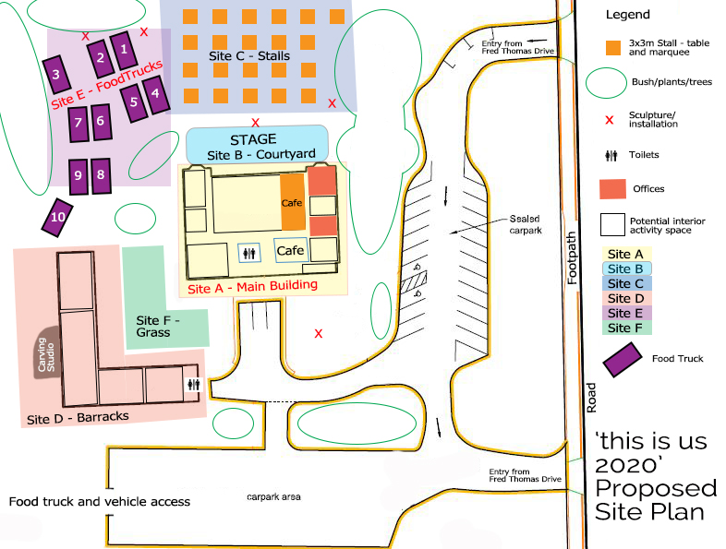
Please email engagement@lakehousearts.co.nz if you have any questions.

